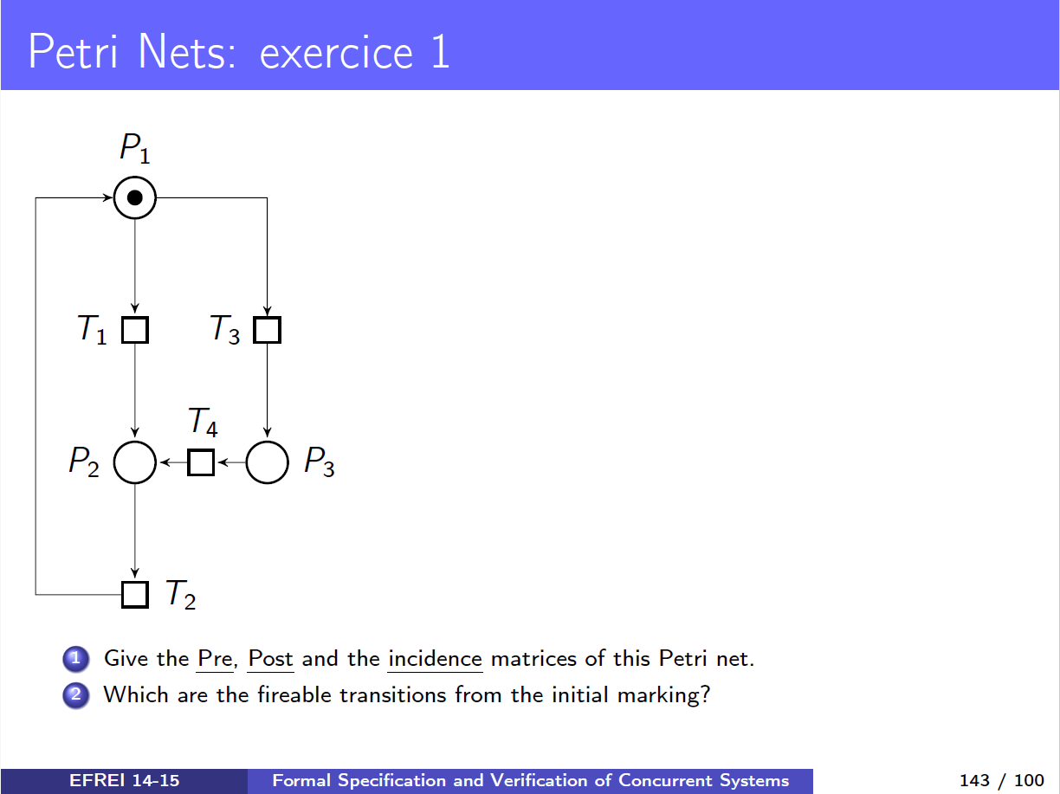

### Question 1.1) The PRE matrice

|  |  |  |  |  |
| --- | --- | --- | --- | --- |
|  | T1 | T2 | T3 | T4 |
| P1 | 1 | 0 | 1 | 0 |
| P2 | 0 | 1 | 0 | 0 |
| P3 | 0 | 0 | 0 | 1 |

The PRE matrice defines the arcs that Goes = Places to the transistions

### Question 1.2) The POST matrice

|  |  |  |  |  |
| --- | --- | --- | --- | --- |
|  | T1 | T2 | T3 | T4 |
| P1 | 0 | 1 | 0 | 0 |
| P2 | 1 | 0 | 0 | 1 |
| P3 | 0 | 0 | 1 | 0 |

### The POST matrice defines the arcs taht Goes = Transitions to the Places

### Question 1.3) The incidence matrice C

|  |  |  |  |  |
| --- | --- | --- | --- | --- |
|  | T1 | T2 | T3 | T4 |
| P1 | -1 | 1 | -1 | 0 |
| P2 | 1 | -1 | 0 | 1 |
| P3 | 0 | 0 | 1 | -1 |

The Incidence matrice is defined by C = POST - PRE

[ -1 ] → Pn vers Tn (sortante); [ 1 ]→ Tn vers Pn (entrante);

### Question 2) Which are the fireable transitions from the initial marking ?

T1 and T3 are the two fireable transitions from the initial marking because m(P1) = 1.